**Recommender Systems: Deep Learning**

**Restricted Boltzmann Machines**

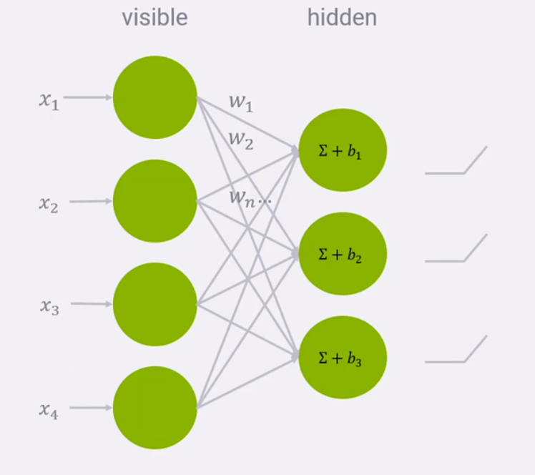

* Sparse data is a major problem here although many new methods have been created to tackle this issue.

**Session-based with RNNs**

* Example is clickstream recommendations.
* RNN will predict sequences